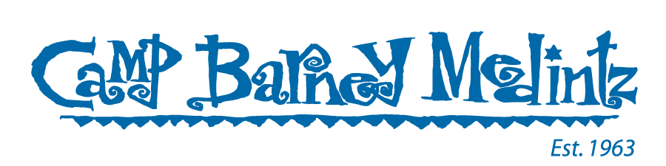
* THESE ARE UPDATED INSTRUCTIONS.
If you are a staff member who has already taken your test ahead of coming to camp, you will be asked to show your negative test results when you arrive. Results will come in an email from eMed.

Dear Camp Barney Medintz Campers & Staff,

Inside this packet is your “Welcome to Camp” eMed Covid-19 proctored self-test. This test should be used within 24 hours of your arrival at camp – and only within the 24 hours ahead of camp. This test is done virtually with a proctor watching you take the test. A second proctor will review the test with you 15 minutes after taking the test. You will then be sent the results of the test via email.

Taking the test – IMPORTANT INSTRUCTIONS:

When you are ready to take the test, you will need a device to video call the proctor. We suggest using a cell phone or tablet for mobility. You will need to move it around so the proctor can see the test on a flat surface and see your face at different times.
- Log into eMed - Camp Barney Medintz
- Create your own account & password
- Click “Skip” when prompted to connect to Navica

The proctor will walk you through all other steps. Please have ID ready. Parents and guardians can vouch for minor children.

VERY IMPORTANT - DO NOT OPEN THIS TEST UNTIL YOU ARE ON THE VIRTUAL CALL AND INSTRUCTED TO OPEN THE TEST BY THE PROCTOR.
Opening the test ahead of time invalidates the results. Replacement tests are not available. If your test is invalidated, you will need to go to a lab-certified testing location to take a rapid antigen test and receive results within 24 hours of your arrival at camp.

YOU WILL BE REQUIRED TO SHOW YOUR NEGATIVE TEST RESULTS UPON ARRIVAL AT THE BUSES, AT CAMP (FOR STAFF), OR AT THE AIRPORT.

IF YOU HAVE A POSITIVE TEST RESULT FROM WITHIN THE PAST 10 DAYS, YOU SHOULD NOT COME TO CAMP AND SHOULD EMAIL SHIRA@CAMPBARNEY.ORG AND SUMMER@CAMPBARNEY.ORG TO DISCUSS NEXT STEPS.

- If you tested positive within the past month and you think you may test positive on the eMed test, please email shira@campbarney.org and summer@campbarney.org ahead of taking the eMed test.

Additionally, if you have not already done so, make sure to go into CampInTouch and upload proof of your camper’s or staff’s vaccination cards and boosters (where eligible). This is mandatory to come to camp. Please direct any questions to shira@campbarney.org and summer@campbarney.org.
We can’t wait to see you at Our Summer Place very soon!
The Camp Barney Medintz Team

