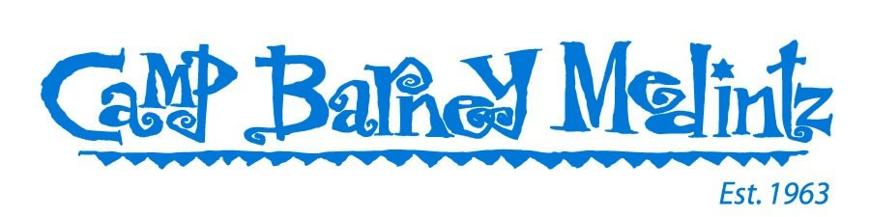
COVID-19 Q & A
Do I need to get vaccinated?
Yes. All campers, staff, and visitors to Camp Barney Medintz need to be vaccinated to the highest level possible.
- “Highest level” is defined as follows:
- For anyone aged 13 and up who received Pfizer: two (2) vaccination shots plus a booster if the 2nd shot was more than five (5) months ago
- For anyone aged 17 and up who received Moderna or a vaccine approved by the World Health Organization (WHO): two (2) vaccination shots plus a booster if the 2nd shot was more than five (5) months ago
- For anyone aged 17 and up who received Johnson & Johnson: one (1) vaccination shot plus a booster if the shot was more than five (5) months ago
- For anyone aged 5-12: two (2) vaccination shots

Do I need to get a booster shot?
Camp Barney follows CDC (Center for Disease Control) guidelines. Based on these guidelines as of 5/20/2022, campers and staff should have a booster shot if they are aged 13 and up and received their 2nd covid vaccination shot more than five (5) months ago.
- The FDA recently approved COVID-19 booster shots for children 5-12 years of age. Since the FDA announced this amendment so close to the camp season, Camp Barney Medintz encourages children 5-12 years of age attending camp this summer to receive this booster but will not require it.
CDC Guidelines can be found here - CDC Guidelines

Where do I submit proof of my vaccinations & booster?
Go to CampInTouch – Current Families – Account Log In. Once logged in, click on Forms & Documents and select COVID-19 Vaccination Card. Upload your card here.
** If your booster shot is listed on a separate card or the back of your COVID-19 vaccination card, use the COVID-19 Vaccination Card – BACK field to upload a second card or the back of your card. If the back of your vaccination card is blank or if it lists the date of your scheduled 2nd vaccination, there is no need to upload the back of the card.

What happens if my camper or staff member tests positive prior to coming to camp?
Camp Barney is following CDC guidelines. Current guidelines say that individuals who test positive need to quarantine for five (5) days and then wear a mask for five (5) days. In order to be as safe as possible, if a camper or staff member tests positive prior to coming to camp, they need to get a PCR (lab) test done and then they may come to camp after 10 days from the point of the positive PCR test.
If someone tested positive on or after May 4, 2022, and thinks they may test positive on the eMed test taken in the 24 hours prior to arrival at camp, send a picture of the initial dated positive test result to marcushealthcenter@campbarney.org. You may be asked to present the same picture at the buses.
· If you do not have a picture of your dated positive test result and you test positive on the eMed test, you should not come to camp for 10 days. Call the camp office at (706) 865-2715 to discuss next steps.

What happens if my camper or staff member tests positive prior to coming to camp and has NOT yet gotten the required booster shot?
If a camper or staff member tests positive in the weeks prior to coming to camp and has not received a booster shot yet, and that camper or staff member is eligible for a booster shot, then the camper or staff member will need to send a picture of a dated positive test to marcushealthcenter@campbarney.org.
- If the positive test was within 90 days of coming to camp, current medical recommendations are to not get a booster shot until 90 days from the positive test has passed. If the camper or staff member is due to come to camp during that 90-day period, then that individual will not be required to get a booster shot. Current medical guidelines indicate the individual will have additional immunity from having recently had COVID.
- At home rapid antigen tests will NOT be accepted as proof of positive test. The individual must provide PCR test results.
- If no test date is provided in the picture of the positive test, then the date the picture was submitted will be considered the date of the positive test.

_____________________________________________________________________________
AT CAMP:
Will masks be required at camp?
No, we are not requiring masks this summer. Individuals are welcome to wear masks if they feel more comfortable in them.
The one exception is if a camper or staff person tests positive for COVID-19 and others are identified as close contacts. Those who are identified as close contacts will be tested immediately and will need to wear a mask until they test negative again four days later. See below for more detail.

Will COVID-19 tests be done on day 4 of camp in 2022 as was done last summer?
No. As everyone at camp will be vaccinated to the highest level, we are not doing repeat testing on day 4 of each session this summer.

Under what circumstances will COVID-19 tests be administered?
Anyone who has a fever, sore throat, or if multiple individuals in a cabin are suffering from similar cold-like symptoms.

If my camper or staff member tests positive for COVID-19 at camp, what happens?
If someone tests positive during camp, that individual will be isolated in the Marcus Health Center and cared for by the Marcus Health Center medical team until the individual can be picked up. The individual’s parents will be called immediately and will need to be picked up within 24 hours of the call.
If the parents cannot be reached, the person’s emergency contacts will be called. If a parent cannot get to camp within 24 hours, the parents will need to arrange for an emergency contact to pick up the camper or staff member within 24 hours. (If a parent lives out of state, we suggest the family identify friends or others who live closer to camp and who can be available to pick someone up in the event of a positive COVID case.)
The camper or staff member will be allowed to return to camp after 10 days so long as the individual is no longer presenting symptoms. Contact summer@campbarney.org to arrange for returning to camp.

If another camper or staff member tests positive for COVID-19 at camp, what happens?
If someone tests positive for Covid-19, that person will be isolated in the Marcus Health Center and cared for by the Marcus Health Center medical team until the person can be picked up (within 24 hours of a positive test).

Campers and staff who were in close contact with an individual who tested positive will also be tested for COVID-19. “Close contact” is defined as campers and staff in the same cabin or half cabin, and any individuals who spent more than 15 minutes indoors with the individual within the 24-hour period prior to the person testing positive. If multiple test positive in a cabin, then we will test the individuals who eat at the tables immediately surrounding the cabin that contains the positive cases.

What happens if my camper or staff member is considered a close contact?
If campers or staff members are identified as close contacts to someone who tested positive for COVID-19, then those campers and staff members will be tested immediately following identification as a close contact and, if negative, again on day 4 after the initial test.

Close contacts will be required to wear a mask around camp except when eating, showering, brushing teeth, sleeping, or doing activities that are solely with other close contacts (i.e., if a cabin is all deemed as close contacts and they are at an activity by themselves).
- Close contacts will do activities without other cabins around, as much as possible, until they retest on day 4.
- Close contacts will be isolated during meals until they can retest on day 4.

Close contacts will be retested on day 4 after an initial test or earlier if they begin showing symptoms. If close contacts test negative on Day 4, they will be cleared to resume normal activities.

